Fishing Trawler “Emma 2”

Shane Nicklaus
sdnickla@nps.navy.mil

29 September 2000

MV 4205 Advanced VRML/X3D Modeling

My task was to model a fishing trawler for the MV 4204 Periscope Project. Having no luck finding fishing trawlers on Jane’s Online, I began an internet search The ship I ended up modeling was found on a for sale site, and was the best picture I could find at the time. The actual site was http://www.ships-for-sale.com/fishing_trawler.htm. Having no line drawings, and only a picture of the starboard side of the ship taken from a distance at about a 30 degree angle, posed some challenges in interpreting ship dimensions and features. While I did know that the ship was 38 meters long, the rest of the information was in French (at least I think it is French). Lacking the ability to read whatever foreign language it was, I “best guessed” the rest.
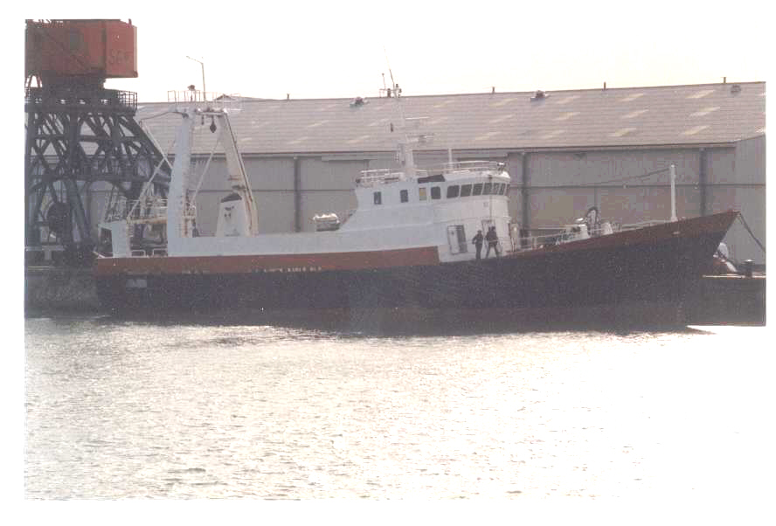
Methodology: I began by taking the picture from the internet and loading it into Sierra Print Artist. I then inserted a grid on top of it, and counted the meters per square based on the fact the ship was 38 meters long. My grid came out to approximately 3.3 meters per square. I set the zero point amidships and counted 19 meters along the positive and negative X-axis. I then determined the hull to be about four (4) meters from the waterline to the top. I used the same method to determine the rest of the dimensions to the closest of my ability due to the ship being on an angle and only having a side view. I approximated the width of the hull to be eight (8) meters. Having done all that, I plotted points on graph paper and began to build it using X3D.

The hull is made from six separate extrusions. The bottom hull was made with cross section points at 0 4, .65 3.5, .65 -3.5, 0 -4, 0 4 and spine points at -18.3 0 0, 0 0 0, 3.5 0 0, 18 0 0. The spine did not extend to the full 19 and –19 points along the X-axis because orientation and scaling was used that made the hull “pointy” at the front, and also angled it in the front and back. The angled parts of the hull reach the 19 and –19 points, thereby making up the 38 meters. The center hull was done similarly with minor changes in cross section, scaling and orientation. The upper hull pieces in the back of the ship are each mirrored extrusions. The cross section is simply -3.514 4, -2.464 4 with the spine stopping at 1.5 on the positive X-axis. This enabled me to extrude the hull over a simple line instead of “filling in” the hull across the entire ship. By turning the X3D solid option to “false”, both sides of the hull piece became visible. The front hull pieces were a little trickier, but were extruded similar to the rear pieces. In addition to extruding them, I transformed them twice in order to get rotations along the Y and Z axes. The forward hull pieces still need to “come together” at the bow of the ship (I said it was tricky!).

The pilot house is an extrusion that has been rotated 90 degrees on the Z-axis. Solid has been set to “false” so the viewer can actually “enter” the pilot house by zooming in there. What they will see is all the “junk” that is currently penetrating the structure. Crease angle has been set to 70 in order to smooth out the structure as much as possible.

All of the rest of the ship was built using transforms and basic shapes- primarily boxes and cylinders with a cone or two thrown in. The windows were also tricky. I used boxes that had to go around the pilot house (future improvements will use Indexed Face Sets). Each box had to be angled as windows inched their way around the curved surface. Two windows landed right on a crease. For these, I made two windows, each scaled in half, just offset from each other. This made a half window on each side of the crease which met in the middle, looking like one regular sized window.

Unfinished business: Aside from cleaning up earlier “mistakes” and changing some things around to make the ship look more aesthetically pleasing, there are still some things that need to be completed. The following is a list: guard rails between forward and aft hull sections, guard rails on the top of the pilot house, radar on top of large pilot house antenna mast, and adding winches.
